# Use Cases

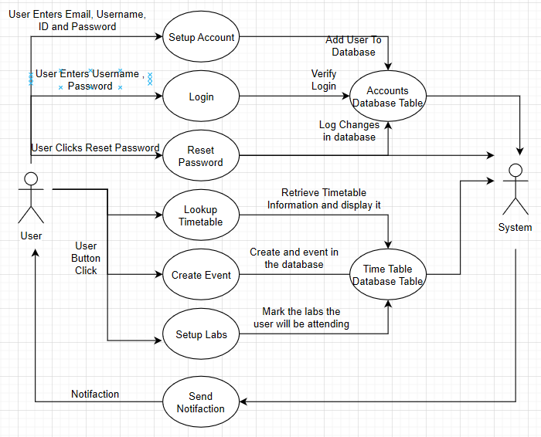

|  |  |
| --- | --- |
| Use Case Name | Setup Account |
| Actor | User |
| Stakeholder | User |
| Primary Actor | User |
| Preconditions | Must not be logged in |
| Triggers | User want to set up account for first time |
| Success Path | User enters Course details and create name and password |
| Failure Path | User restarts the use case or quits |

|  |  |
| --- | --- |
| Use Case Name | Login |
| Actor | User |
| Stakeholder | User |
| Primary Actor | User |
| Preconditions | Must not be logged in |
| Triggers | User want to log in |
| Success Path | The user will enter name and password and log into the app |
| Failure Path | User restarts the use case or quits |

|  |  |
| --- | --- |
| Use Case Name | Lookup Timetable |
| Actor | User |
| Stakeholder | User |
| Primary Actor | User |
| Preconditions | Must be logged in |
| Triggers | User clicks to see there setup timetable |
| Success Path | Will display next events for that week or day to the user |
| Failure Path |  |

|  |  |
| --- | --- |
| Use Case Name | Create Meeting |
| Actor | User |
| Stakeholder | User |
| Primary Actor | User |
| Preconditions | Must be logged in |
| Triggers | User clicks to create a meeting on their timetable |
| Success Path | User enters the meeting time and selects if it is repeatable, this is then added as an event |
| Failure Path | User restarts the use case or quits |

|  |  |
| --- | --- |
| Use Case Name | Create Labs |
| Actor | User |
| Stakeholder | User |
| Primary Actor | User |
| Preconditions | Must be logged in |
| Triggers | User clicks to select what labs for the course they are attending |
| Success Path | User enters there lab type and the labs are added to their scheduled events |
| Failure Path | Labs are successfully created and changes will not be saved |

|  |  |
| --- | --- |
| Use Case Name | Receive Notification |
| Actor | System |
| Stakeholder | User |
| Primary Actor | System |
| Preconditions | Event that needs to be attended |
| Triggers | Time is close to next event time |
| Success Path | The user will be notified of the event |
| Failure Path |  |